PRACTICE 4: SAVE DOM AS XML FILE

## OBJECTIVE:

We have a DOM tree in main memory and we want to create an XML file from it. That is called Serialization.

## PRACTICE:

1. We will use the classes:

- OutputFormat, which es a deprectated API (see annexed file explaining how to solve the problem.)

- XMLSerializer: method serialize(Document doc) will create the xml file with the contents of doc.

2. The resulting code is:

**public** **int** saveDOMasFile(String fileName){

**try**{

File fxml=**new** File(fileName);

OutputFormat format = **new** OutputFormat(doc);

format.setIndenting(**true**);

**XMLSerializer serializer**= **new** XMLSerializer(**new** FileOutputStream(fxml),format);

serializer.serialize(doc);

System.***out***.println(fileName+" file XML created from DOM succesfully.");

**return** 0;

}**catch**(Exception e){

System.***out***.println(e);

**return** -1;

}

}

**OutputFormat** gives an error.

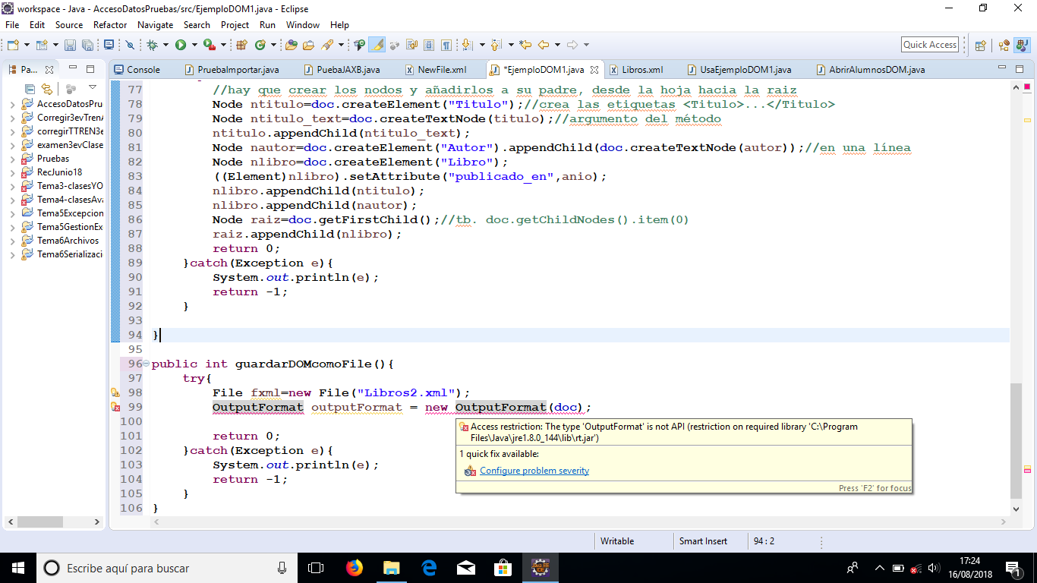

To solve it:

1. **import** com.sun.org.apache.xml.internal.serialize.*;
2. **Change**  **Settings:**
   1. **Got to Project>Propertirs:** Look for “deprecated API” and change from error to warning.

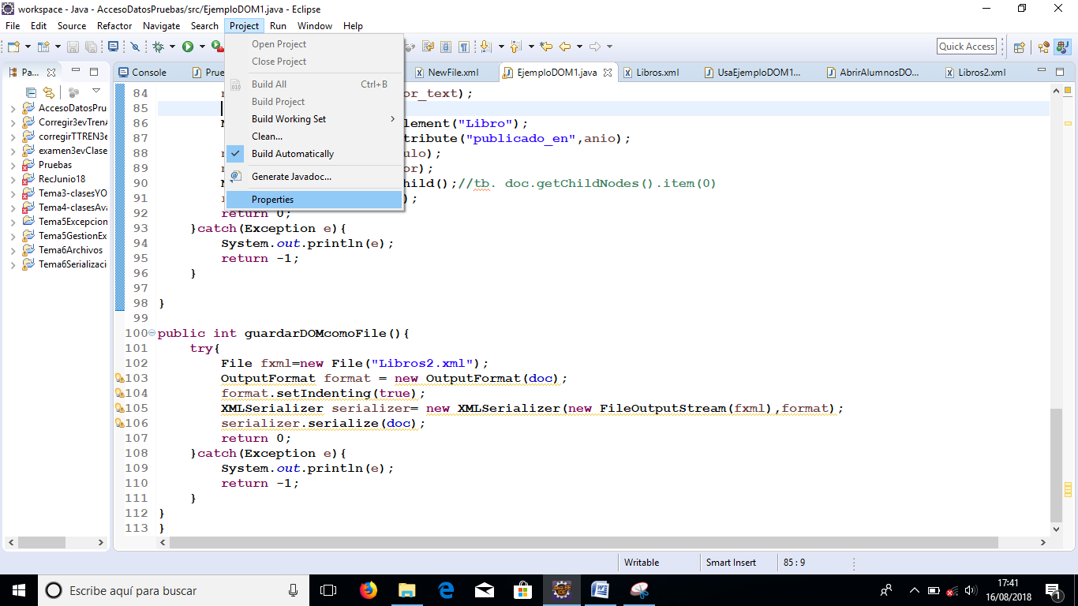

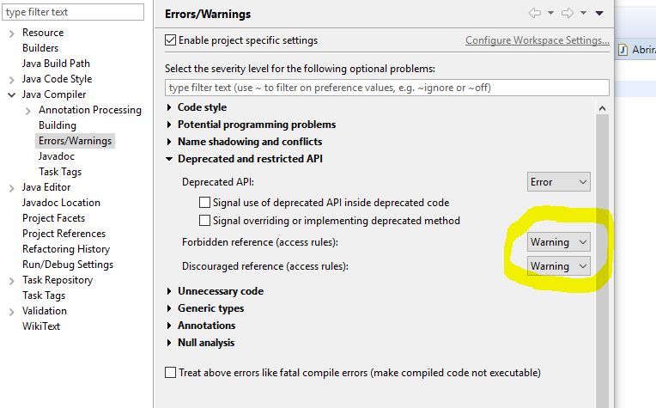

This will let us run our code

3. Now, we will try if it works in the class UseXMLtoDOM:

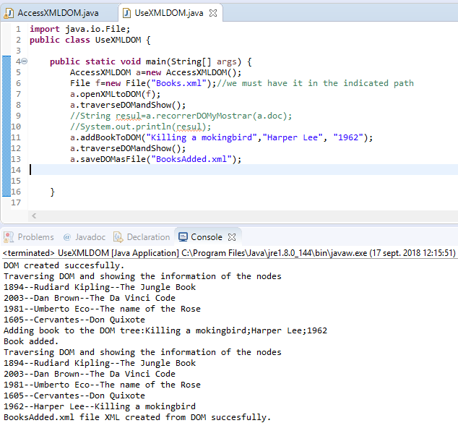

If we check our files inside src, we must have the new file:

